



**Module Code & Module Title**

**CS6P05 Final Year Project**

**Assessment Weightage & Type**

**5% FYP Proposal**

**Semester**

**2024 Autumn**

**PROJECT TITLE: EDUSYNC (AI SMART CLASSROOM)**

**Student Name: Miraj Deep Bhandari**

**London Met ID: 22067814**

**College ID: np01cp4a220197**

**Internal Supervisor: Mr. Rubin Thapa**

**External Supervisor: Mr. Subash Basnet**

**Assignment Due Date:**

**Assignment Submission Date:**

**Word Count: 1850 words**

*I confirm that I understand my coursework needs to be submitted online via Google Classroom under the relevant module page before the deadline in order for my assignment to be accepted and marked. I am fully aware that late submissions will be treated as non-submission and a mark of zero will be awarded.*

Table of Contents

1. Introduction 1

1.1 Problem Scenarios 1

1.2 The Project as a Solution 2

2. AIM AND OBJECTIVES 3

3. Expected Outcomes and Deliverables 4

3.1 Expected Outcomes 4

3.2 Deliverables 6

4. Project risks, threats and contingency plans 7

5. Methodology 8

6. Resource Requirements 12

6.1 Hardware: 12

6.2 Software: 13

7. Work breakdown structure: 14

8. Milestones: 15

9. Project Gantt chart 16

10. Conclusion 17

11. Bibliography & References 18

# 1. Introduction

EduSync is an AI-based smart classroom application developed for use by schools and colleges serving teachers and students alike. This app enables seamless learning in application, advanced AI tools create contents, detect cheating, take notes, create questions, and much more. It saves time as it boosts productivity, efficiency in education through simplification of day-to-day activities that drive engagement.

## 1.1 Problem Scenarios

The education system in Nepal has been facing a lot of challenges due to very limited integration of technology and a lack of efficient classroom management tools. In such schools, the prevalent outdated methods are affecting teachers' teaching skills and students' potential for digital learning. This negatively affects teaching practices, learning outcomes, and operational efficiency. The exclusionary digital divide increasingly reinforces inequities in education in truly systemic ways between urban and rural settings (Government of Nepal, 2019; Paudel, 2020; ).

Some major issues are:

**a) Lack of Classroom Applications**: Inaccessibility to technology for sharing resources and facilitating online tests and communication between teachers and students. Inadequate tools for submitting assignments, detecting plagiarism, and organizing digital learning.

**b) Limited Use of AI:** Most of the available tools are devoid of advanced AI mechanisms for effective administration, learning pattern identification, and the delivery of customized education experiences.

**c) Cheating and Academic Dishonesty:** The ease of assignments and projects can be directly copied from one student to another person in the class, the misuse of AI tools for homework, which is sometimes difficult to be got caught, leads to violation of academic integrity and learning.

**d)** **Poor Class Management:** Poor Assignment managing systems along with poor attendance and communicating results in low productivity, delayed, and unorganised. This doesn't counter with productivity tools and education transparency-confirmation.

## 1.2 The Project as a Solution

AI Smart Classroom (EduSync) can solve the problem above. In context to the above mentioned challenge, EduSync has a series of web-based and AI-powered features, as follows :

1. **Posting :** Posts can be created by students and teachers.
2. **Syllabus:** Educators exchange notes such as notebooks and learning resources.
3. **Homework:** Homework can be assigned, and submitted via the platform.
4. **Attendance:** Attendance is marked through facial recognition .It can be edited manually in case of need.
5. **Slide Generation :** Teachers generate a lecture slide on a specific topic**.**
6. **Detect Plagiarism & AI:** Teachers Find Plagiarism & AI in Assignments
7. **Generation of MCQ & Note:** MCQ can be generated by the teacher and Note can made by student from Lecture Slides.
8. **Notebook Interaction :** Students chat with notebooks for better learning.
9. **Chatbot Support:** A chatbot solves inquiries of teachers and learners.

# 2. AIM AND OBJECTIVES

**AIM:**

The main aim of Edusync is to implement the classroom management system with AI that would provide students and teachers to automate their activities in the classroom. It integrates AI and web technologies to create class posts, submit assignments, examinations, manage attendance, sharing of resources, generating resources, detecting cheating, and support using chatbots.

**OBJECTIVES:**

1. Implement the feature to create posts and allow interactions such as likes and comments.
2. Implement the feature for an assignment portal to facilitate the creation and submission of assignments**.**
3. Automate attendance and participation tracking using facial recognition technology, with the ability to manually edit attendance records
4. Implement NLP for plagiarism detection through the integration of transformers
5. Build AI content detection using the RoBERTa-BERT architecture on the GPTBench2 dataset, along with other open-source datasets available on Hugging Face
6. Build a feature that allows teachers to generate PowerPoint (PPT) presentation slides for their lecture content
7. Implement the advanced Agentic RAG (Retrieval-Augmented Generation) system, allowing students to query their lecture and tutorial notebooks.
8. Implement the LLM with llama Index and Langchain for generating the summary of the notebook uploaded by the student of their lectures and tutorial classes
9. Implement a system for the automatic generation of MCQs based on content for teachers, and allow students to participate in the MCQ examination.
10. Implement a chatbot for guiding students and teachers, providing assistance with queries, resources, and support related to course content, assignments, and general information.

# 3. Expected Outcomes and Deliverables

Once the EduSync project is finished, the system would provide a broad range of advanced functionalities for improvement of learning processes, study honesty, as well as individual learning experience. Here is a summary of the expected results and deliverables

## 3.1 Expected Outcomes

With the EduSync platform we can provide Integration where organizations can collaborate, learn and administer typical everyday tasks. To clarify, the expected outcomes fall within both Core Features and Side Features:

**Core Features:**

**Interactive Post System**

* Allows teachers and students to create and comment on posts which facilitates smooth communication and collaboration

**Resource Sharing**

* Teachers can quickly upload learning material into the platform for students, such as lecture notes, presentations, and other study resources.

**Assignment Management**

* **For Teachers:** A portal for creating, assigning, and more assignments.
* **For Students:** Streamlined platform-based submission of assignments

**AI-Automated Slide Generation**

* A handy tool that helps you build professional PowerPoint slideshows from your lectures, thus saving you time and ensuring that your presentation is of the highest quality.

**AI-Powered Study Tools**

* **Interactive Querying:** This allows students to query the uploaded notebooks using AI, which can significantly improve the comprehension and outcomes of learning.

**Supportive Side Features:**

**Automated Attendance**

* **Face Recognition:** AI-based face recognition technology to manage attendance.
* **Manual Adjustments:** When required, teachers have the option to make manual edits to attendance records.

**MCQ Functionality**

* **For Teacher:** Automatically Generate-Multiple Choice Questions for exams and quizzes
* **For students:** Simple interface to take MCQ-based exams.

**AI Chatbot Assistance**

* A responsive AI chatbot to assist students and teachers with navigating the system, managing assignments, and answering queries related to resources.

**AI Content Detection**

* Originally designed to detect AI-generated assignments, it was then repurposed to ensure academic integrity and integrity in student submissions.

**Plagiarism Detection**

* It is made up of integrated tools to detect and report copied content to ensure fair evaluation and maintain academic integrity.

## 3.2 Deliverables

1. **Functional Prototype**

A working EduSync prototype demonstrating the core features and side features:

1. Creation and interaction with posts.
2. Share resources, submit and manage assignments.
3. Automated slide generators, plagiarism checkers and AI note generators
4. Conducting attendance and MCQ based exams.
5. **User Guides**

Comprehensive user guides detailing:

1. Steps for setting up, configuring, and using EduSync.
2. Tutorials for students and teachers to maximize the platform's potential.
3. **Technical Documentation**

A detailed technical specification including:

1. Describe the system architecture and components.
2. Data models and flow diagrams.
3. Deployment and maintenance instructions.

# 4. Project risks, threats and contingency plans

Smart Classroom AI development integrating complex features carries multiple risks. Following are the listed risks and the contingency plans outlined for the same:

|  |  |  |  |
| --- | --- | --- | --- |
| **Risk** | **Description** | **Contingency Plan** | **Severity** |
| System Downtime or Training Failure | Application consumes heavy computational resources (GPUs, RAM, VRAM), leading to heating issues | Use of cloud platforms (e.g., AWS, Azure) for AI model training and apply quantization techniques (e.g., INT8, FP16) for Model inference. | High |
| AI Model Bias | AI systems may produce biased results due to limited training time. Large datasets increase cloud storage costs and time complexity. Training a transformer model on **1 million rows** for **1000** **epochs** can take **24,000** **hours** and cost between **$12,624 and $73,440**. | Use a subset of the dataset to implement the training process of the AI model for fewer epochs, while saving the model weights, configurations, and model checkpoints. | Medium |
| Internet Stablity Risks | The training of the model on cloud platforms like Google Colab requires stable internet connectivity. If any issues arise, the model training process might get interrupted | For smooth training of the model, we need to ensure stable internet connectivity, proper monitoring of the ping, and configuration of the model with autosave checkpoints. | High |
| Integration Challenges | The project uses full AI and web components, so we need to sync both components in real-time. In this phase, the system may experience lag due to the large model size. | For integration, we need to conduct pre-testing and use the quantized model or explore cloud storage options for real-time, asynchronous web and AI collaboration. | Medium |

# 5. Methodology

The AI Smart Classroom (EduSync) will be developed and implemented using the **Agile Methodology**, with the **Scrum Framework.** The principles of Agile are extremely useful for AI and web development projects as the Agile methodology delivers built components regularly in incremental and iterative cycles while responding to change of requirements.

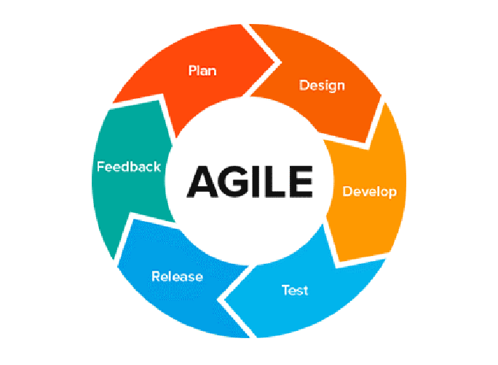

**Scrum:**

Scrum is an Agile framework that organizes work into iterative cycles called sprints (usually 2-4 weeks) (Sachdeva, 2016). Each sprint delivers a working product increment.

**Key Elements:**

1. **Roles:**
2. Product Owner: Prioritized Features (Product Backlog).
3. Scrum Master: Responsible for keeping the team on Scrum, removes roadblocks.
4. Development Team: Develops and tests Product.
5. **Artifacts:**
6. Product Backlog: The product backlog is a collection of features/tasks needed to create the product.
7. Sprint Backlog: Selected features for the current sprint.
8. Increment: The working product delivered at the end of a sprint.
9. **Ceremonies:**
10. Sprint Planning: Focus on goals and tasks for the sprint.
11. Daily Standups: 15 minutes daily meetings to share progress.
12. Sprint Review: Showcase the results of the sprint to stakeholders.
13. Sprint Retrospective: Input where you can improve the next sprint.

**Benefits of Choosing the Agile Framework SCRUM for EDUSYNC are given below:**

1. **Efficient AI Feature Development:**

Scrum has a product backlog, which makes task management easier. Scrum’s iterative approach breaks down EduSync's AI functionalities, such as facial recognition, plagiarism detection, and AI-content identification, into manageable tasks. This ensures thorough testing and integration, reducing technical risks and maintaining quality.

1. **User-Centric Design:**

We do frequent sprint reviews with teachers and students to ensure features like automated slide creation, MCQ generation and notebook summarization really solve problems for real classrooms. Using Scrum will allow us to iterate and develop exactly what they want and believe.

1. **Risk Management and Resource Optimization:**

The scrum controls the risk by providing iterative development and also identifying problems early and adaptive solutions. These include laggy video output or low detection accuracy and are tackled iteratively during sprints, while daily stand-ups enable continuous monitoring of risks. Retrospective is shaping up to refine the strategies as far as getting YOLO to run smoothly, effective async implementation, effective resource utilization towards achieving scalability and responsiveness. Scrum mitigates risk by promoting iterative development, early detection of issues, and adaptive solutions.

**d) Improved Collaboration and Transparency:**

EduSync is an integrated project involving web and AI components. For the effective training of the AI model, I need a suitable dataset and a clear understanding of the business logic that addresses the needs of stakeholders and problem-solving requirements. The Scrum framework allows the design of classroom features and development models by making use of stakeholders' private data. The stakeholders will thus offer useful input on how the institution can integrate databases with both student details and the respective subject information through close collaboration. I also ensure total institutional-level transparency by retaining institutional data ownership, and through enabling stakeholders to track where the usage of their data was channeled in an institutional setting.

# 6. Resource Requirements

The successful development and implementation of the AI Smart Classroom (EduSync) will require the following resources:

## 6.1 Hardware:

|  |  |
| --- | --- |
| **Resource** | **Details** |
| Development Systems | High-performance computers (Intel Core i7/AMD Ryzen 7, 16 GB RAM, 1 TB SSD). |
| GPUs for AI Processing | NVIDIA GPUs (e.g., RTX 3050 or higher) for AI model training and execution. |
| Cloud Infrastructure | AWS, Azure, or Google Cloud for hosting, data storage, and AI computation. |
| User Access Devices | Desktop computers, laptops, tablets, and smartphones (iOS and Android). |
| Peripheral Devices | High-quality webcams for facial recognition and reliable network devices. |

## 6.2 Software:

|  |  |
| --- | --- |
| **Technology** | **Details** |
| IDE | VS code, Jupyter Notebook |
| Frontend requirement | HTML/CSS, JavaScript, Bootstrap |
| Backend requirement | FastApi, Jinja2 , SqlAlchemy, Uvicorn |
| Database | MYSQL |
| Version Control | Github |
| Programming Languages and Frameworks | Python, Pytorch, OpenCV , Dlib, MediaPipe, YOLO, Transformers, Hugging Face, Langchain, LlamaIndex, Scikit-Learn, Keras |

# 7. Work breakdown structure:

# 8. Milestones:

# 9. Project Gantt chart

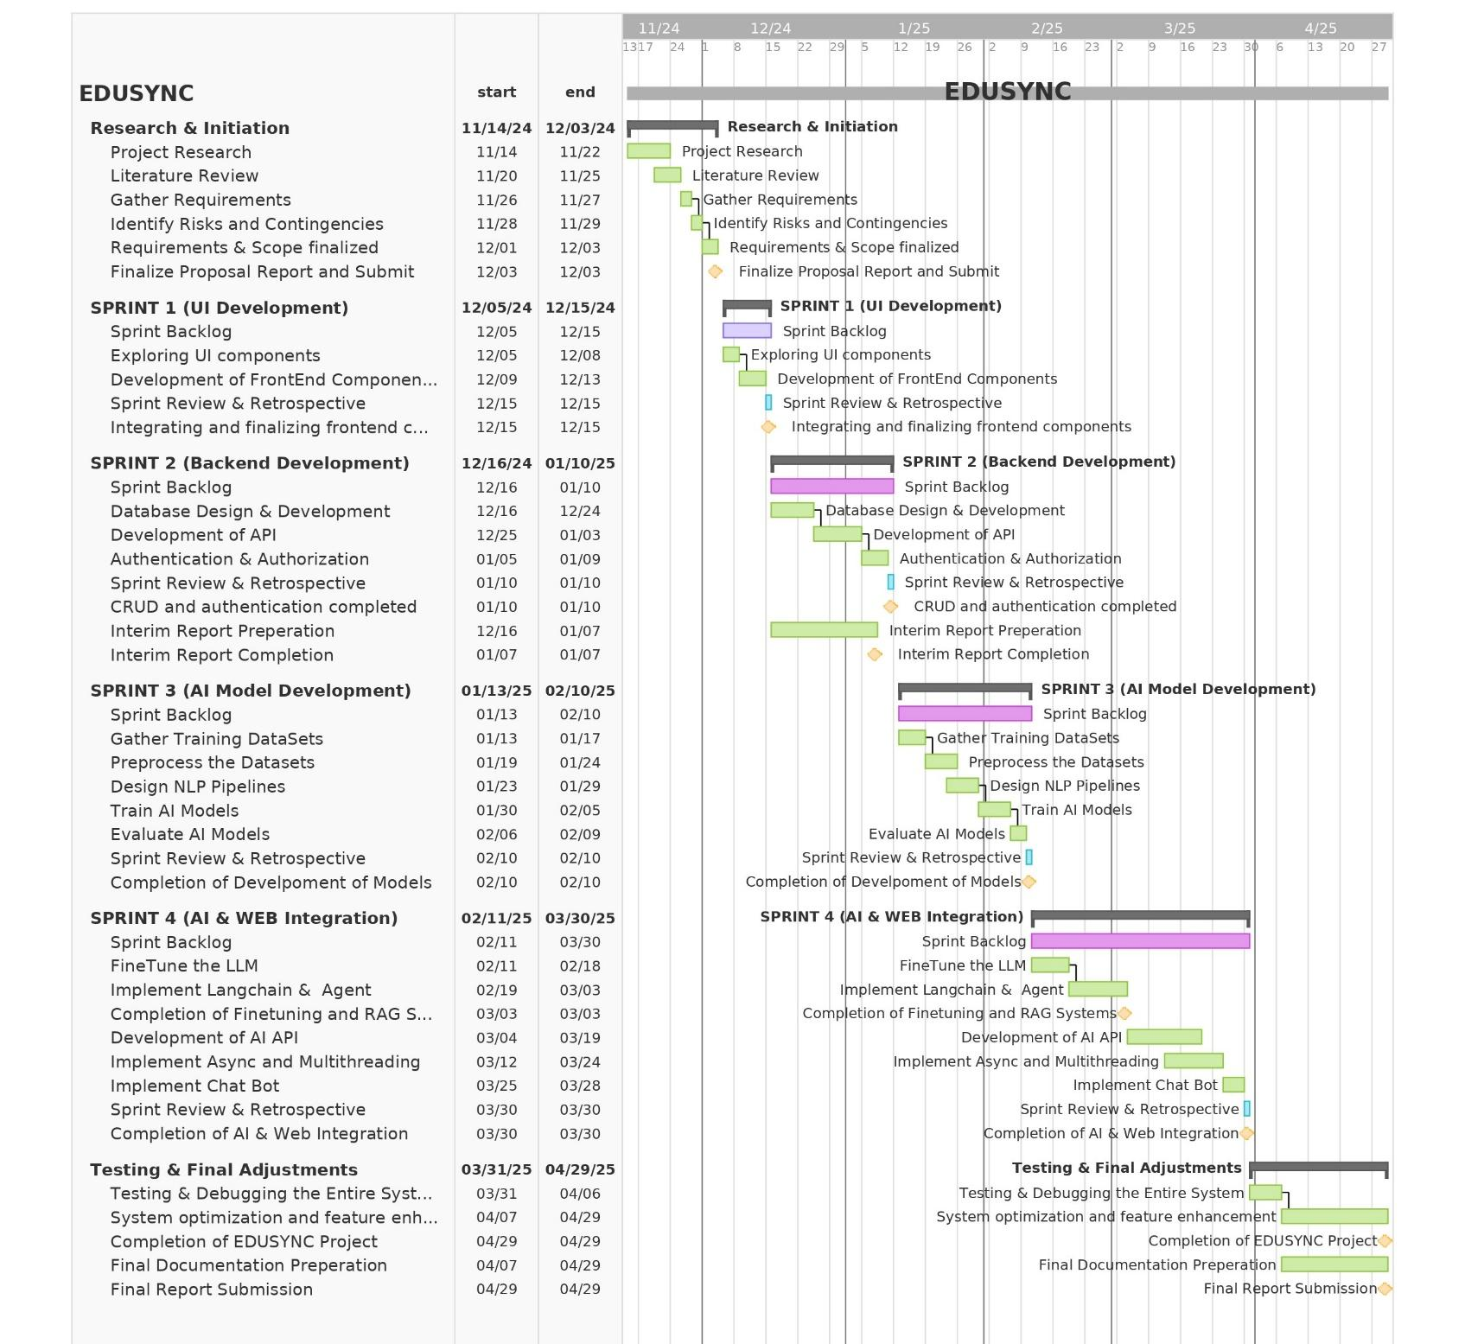

# 10. Conclusion

EduSync aims to change the face of classroom management, merging advanced AI technologies with a simple-to-use web interface. Besides, it tends to target most of the general problems in the educational system, including inefficiency in sharing resources, academic dishonesty, and problems in communication. EduSync automatizes tasks such as tracking attendance, plagiarism detection, content generation, and assignment management, thereby increasing the productivity of teachers and students alike. Therefore, following the Agile methodology, EduSync is flexible, ever-improving to meet user needs. It is the complete solution for many of the major ills which affect modern education.

# 11. Bibliography & References

Government of Nepal, 2019. National Education Policy. Kathmandu: Ministry of Education, Science and Technology.

Paudel, J., 2020. Effectiveness of online education in Nepal: A study of bachelor level students. Delhi Business Review, 21(2), pp.23-30.

University Grants Commission, 2018. Quality assurance and accreditation for higher education in Nepal. Bhaktapur: Janak Education Materials Centre.

Sachdeva, S. (2016). Scrum Methodology. International Journal Of Engineering And Computer Science, 5(6). doi:https://doi.org/10.18535/ijecs/v5i6.11.